A Digital Forensic Tool for Extracting User Activity from Mobile Devices

In this paper author is describing concept to analyse user’s mobile devices for Crime Scene Investigation to know about user’s behaviour in his daily life. Now-a-days almost all users are using mobile devices and this devices contains huge amount of user’s personal activity details, in that context, mobile devices store user’s personal information and even more data, becoming a personal tracker for daily activities that provides important information about the user. Derived from this gathering of information, many tools are available to use on mobile devices, with the restrain that each tool only provides isolated information about a specific application or activity. Therefore, the present work proposes a tool that allows investigators to obtain a complete report and timeline of the activities that were performed on the device. This report incorporates the information provided by many sources into a unique set of data. Also, by means of an example, it is presented the operation of the solution, which shows the feasibility in the use of this tool and shows the way in which investigators have to apply the tool.

In propose paper author is scanning all files from mobile devices to find each file length and columns in excel files and date of file creation and modification and then saving all extracted data as report. To implement same concept we have obtained ‘CHAT LOGS’ dataset from many users and their mobile devices and this chat logs contains data in HTML format with so many garbage and special symbols and then we apply forensic task to recover chat file date and then extract only chat messages from logs and then extract size and length of file. By using this project Crime Scene Investigation we can easily understand in which activity user was involved by reading his chat messages.

Below screen shots showing chat messages used to apply Crime Scene Investigation in this project

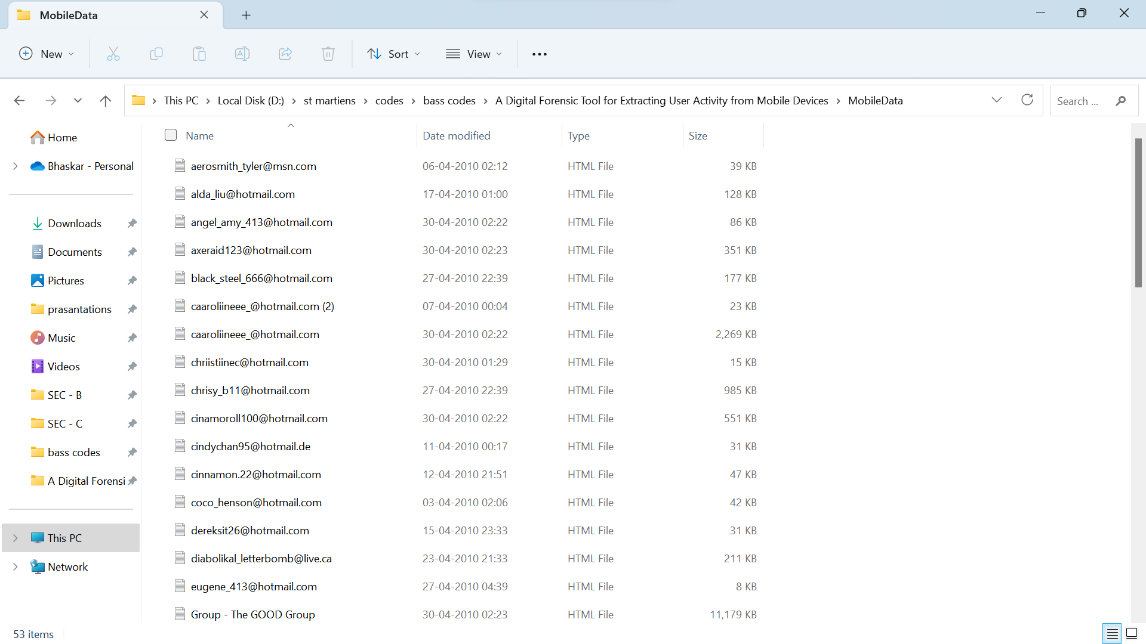

To implement this project we have designed following modules

1. Upload Mobile Data: using this module we will upload chat log HTML messages files to application
2. Extract Data: using this we will extract HTML data from uploaded file and then display content of that file
3. Forensics Activity: using this module we will extract file size, file creation and modification date and number of lines in that file
4. Filter Data: in this module we apply HTML parsers to remove HTML tags from chat logs and then display clean chat messages between users.

SCREEN SHOTS

To run project double click on ‘run.bat’ file to get below screen

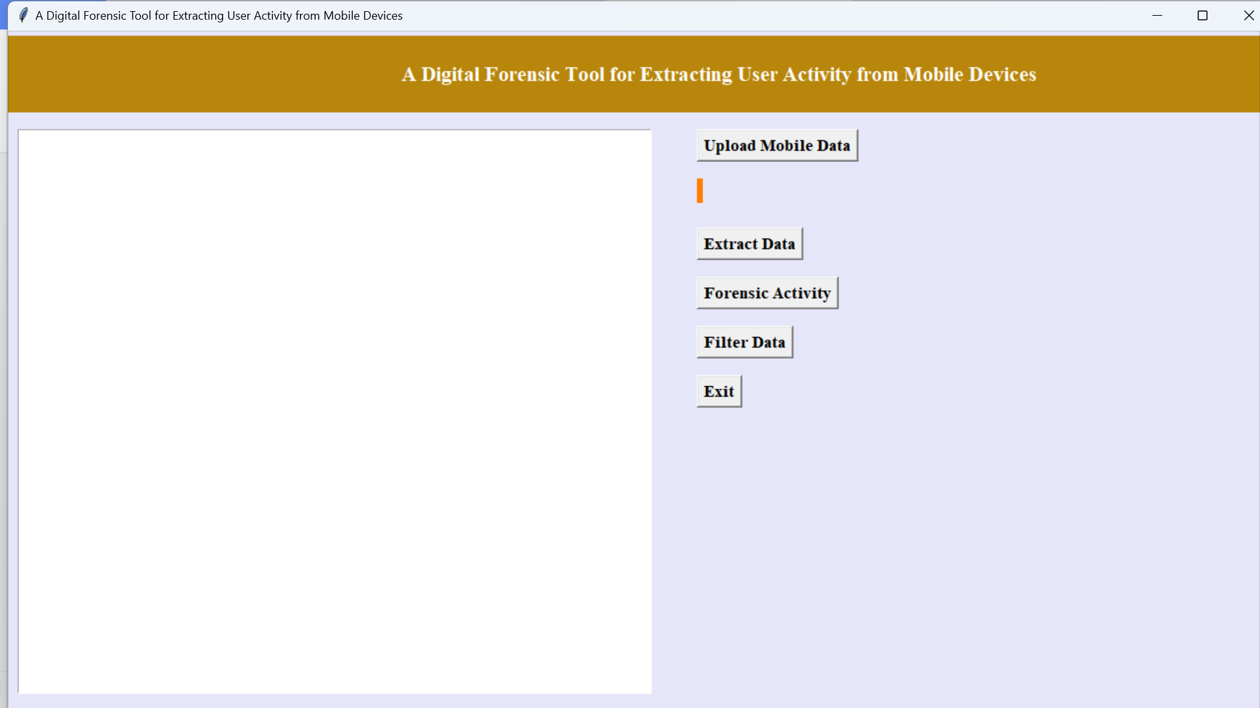

In above screen click on ‘Upload Mobile Data’ button to upload chat log file

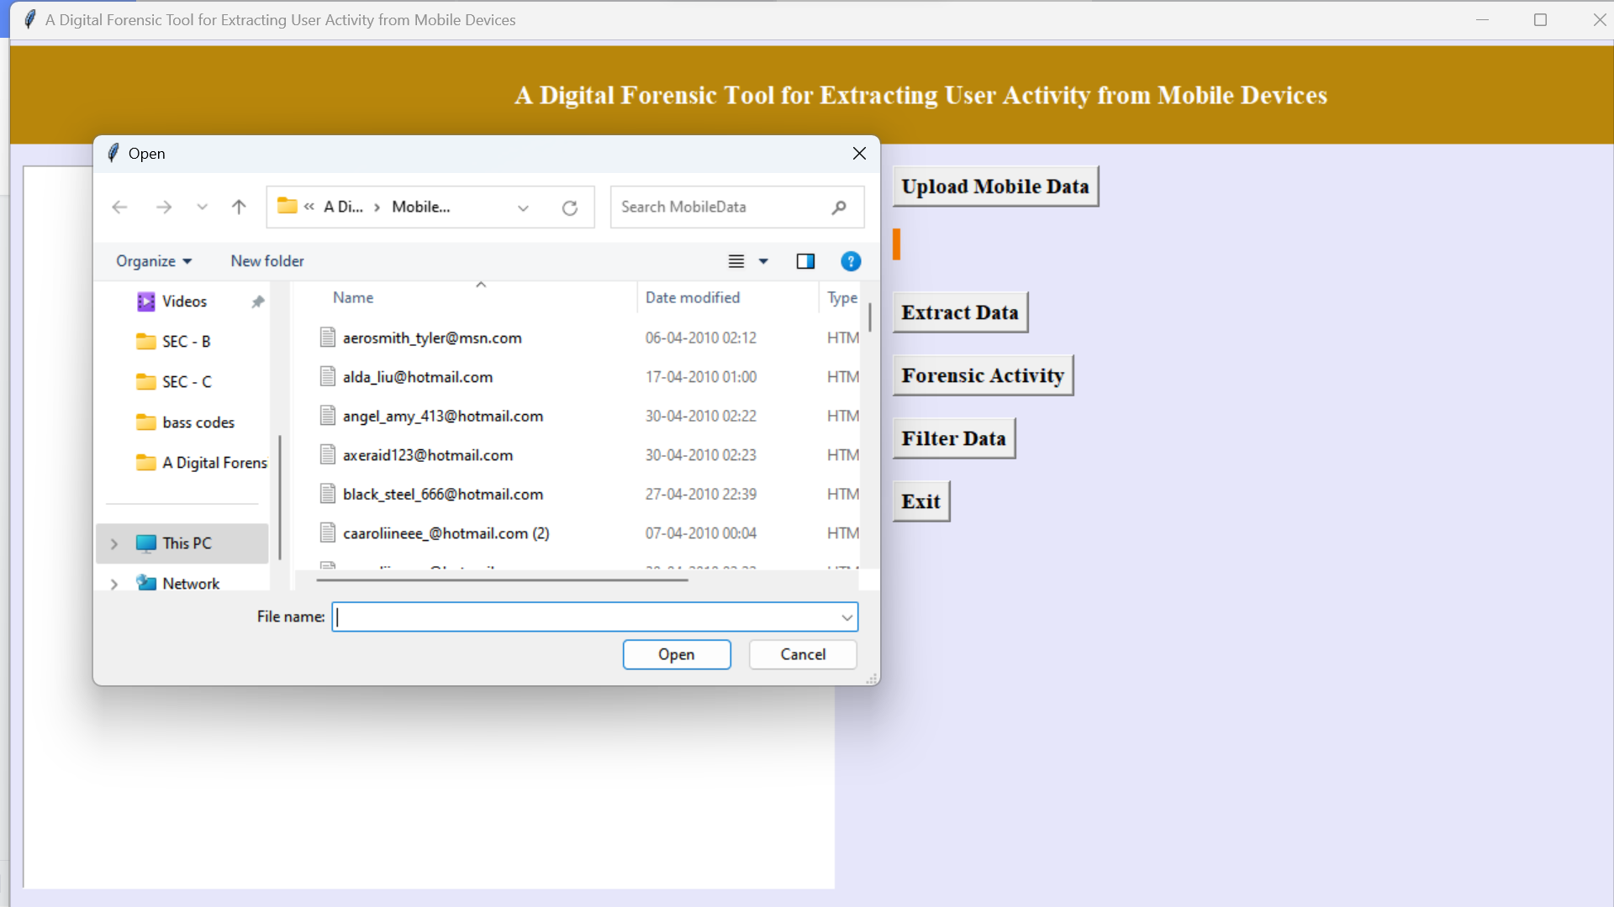

In above screen I am selecting and uploading first chat log file and then click on ‘Open’ button to get below screen

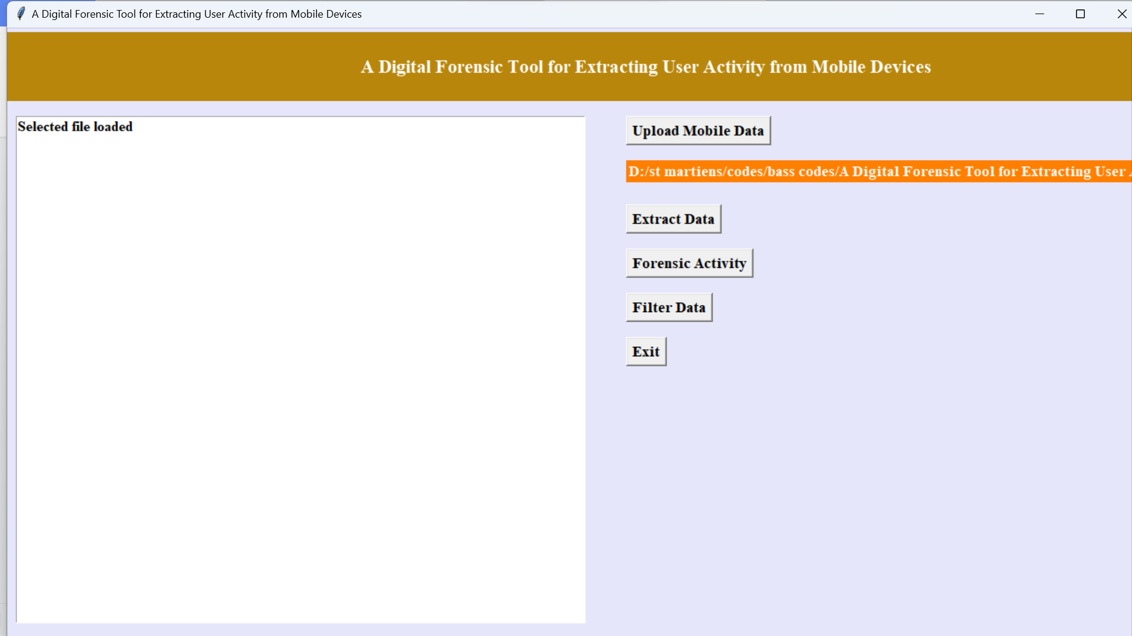

In above screen chat log file is uploaded and now click on ‘Extract Data’ button to extract content from file

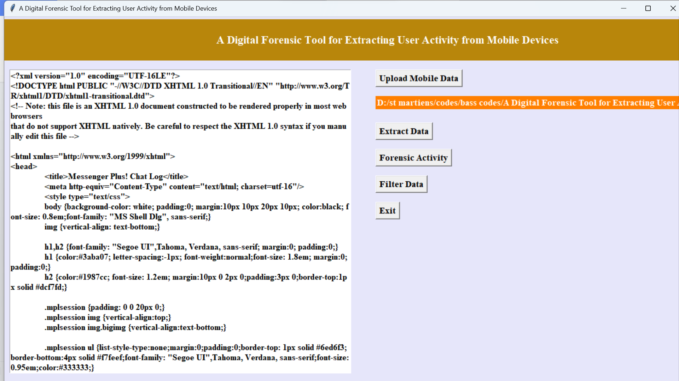

In above screen we can see entire file content is in HTML format and user cannot understand anything from that so click on ‘Apply Forensics Activity’ to extract details from file

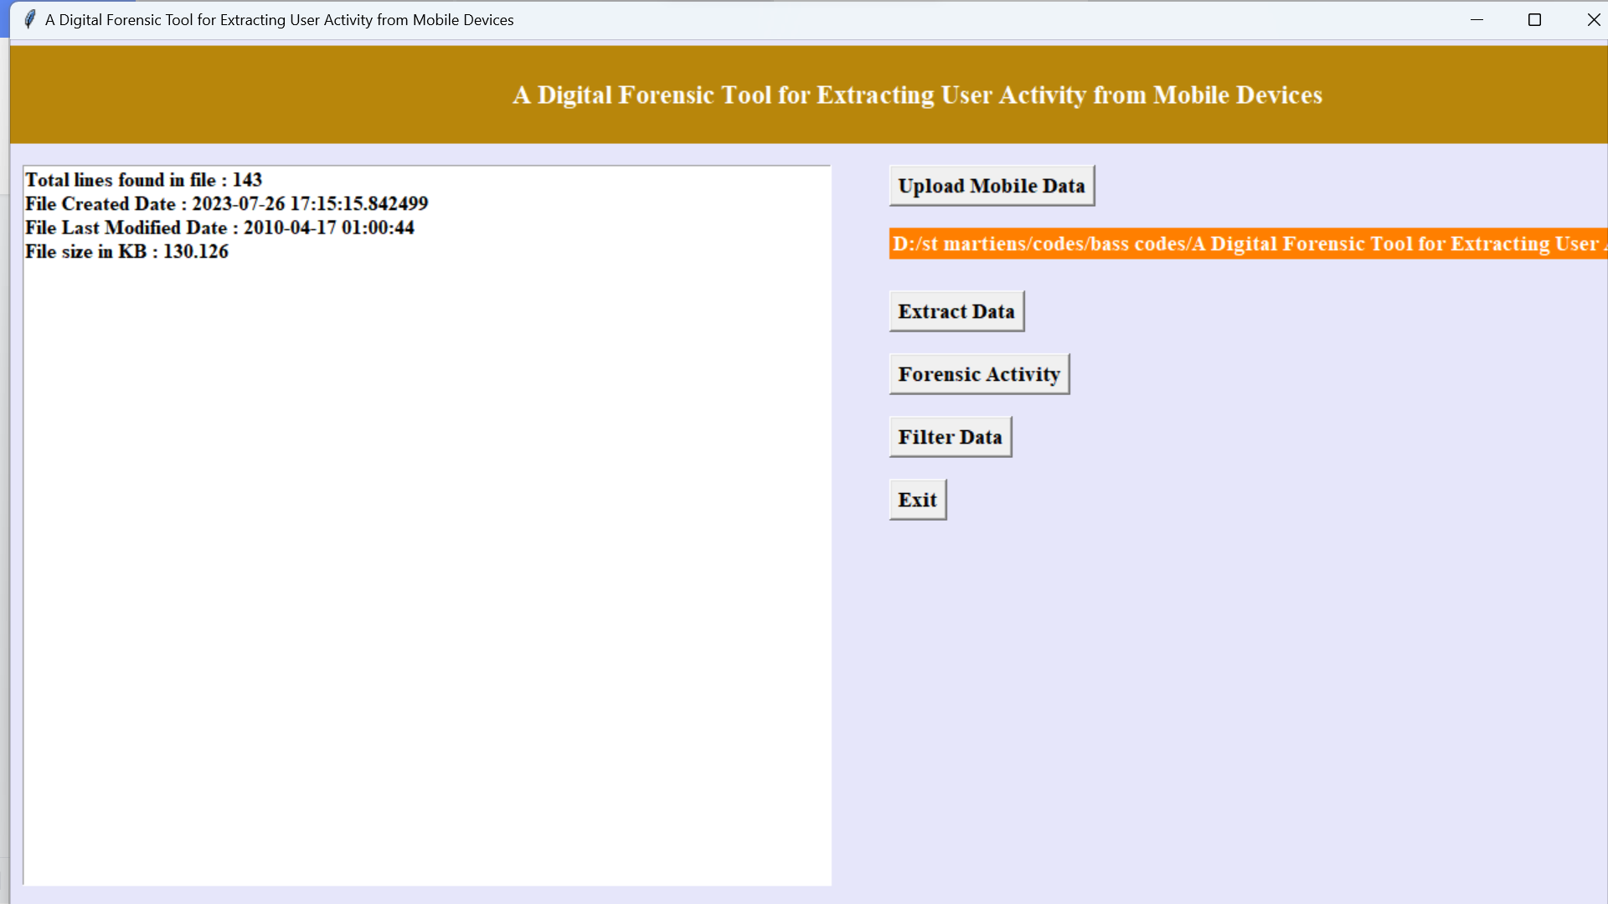

In above screen in first line we can see file contains total 113 lines and we can see file created and modified date and file size is 39.272 KB and now we extracted all details and now click on ‘Filter Data’ button to removed out all HTML tags to clean chat message like below screen

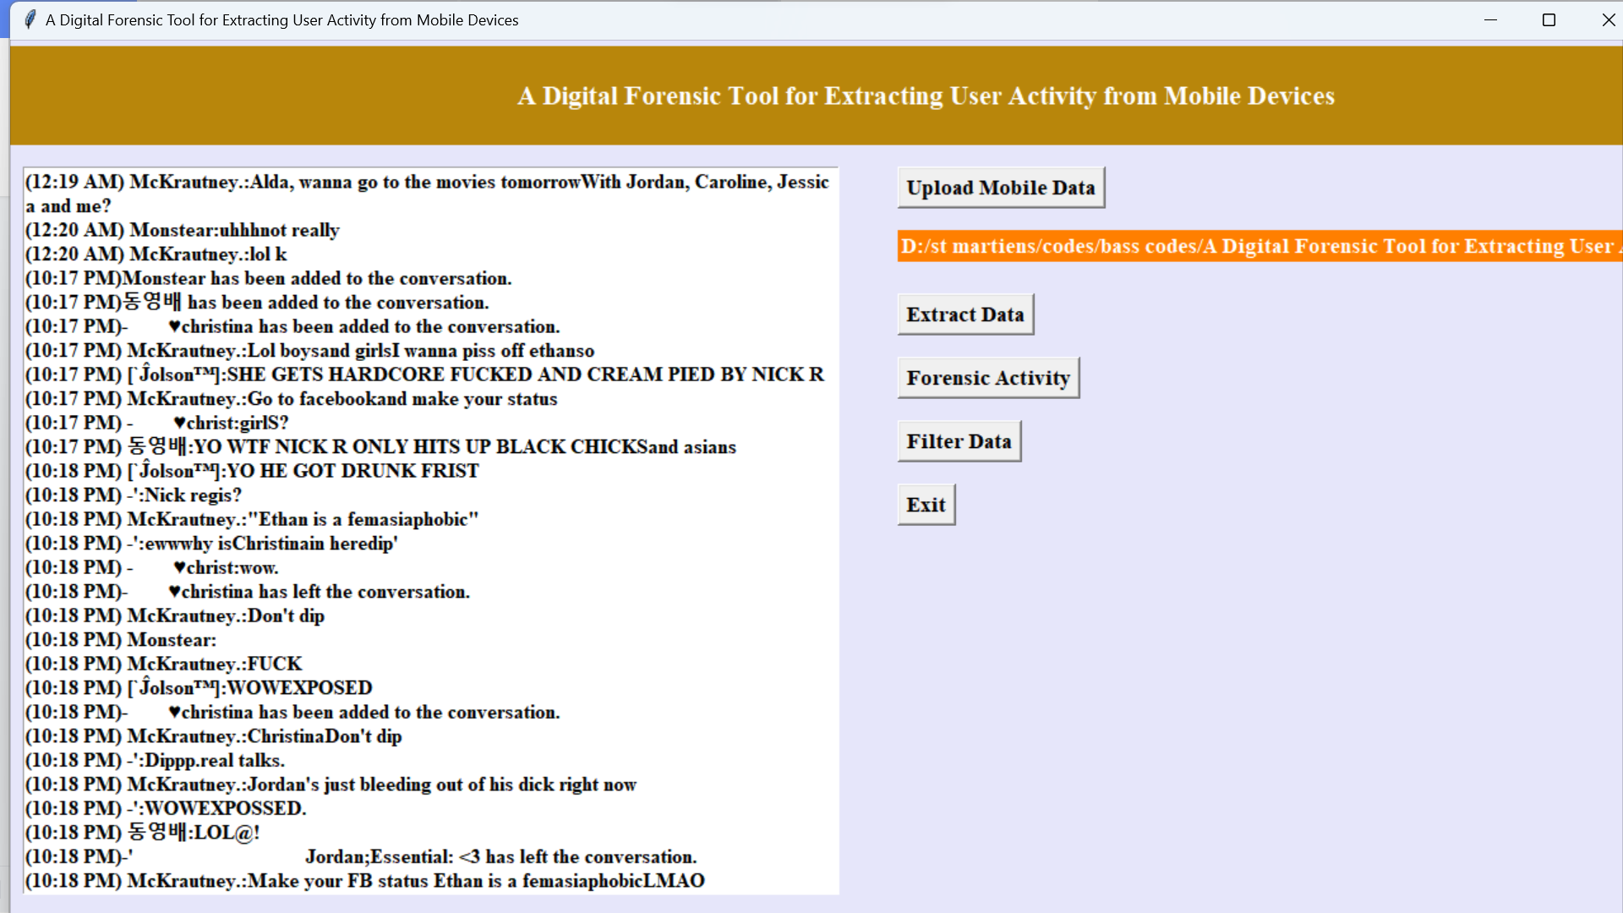

In above screen from HTML content we extracted chat messages and user can read above messages clearly. So by applying Crime Scene Investigation logger we have clean chat messages from HTML tags. Similarly you can upload other file and extract messages. Now see other files.